TASK 32 :DECLARATIVE PIPELINE FOR BUILDING, TESTING, PACKAGING, VERIFY A COMPLEX JAVA APPLICATION

• Activity: • Create a declarative pipeline to build,test, package, verify a spring pet clinic application • Steps: • Create a pipeline project DeclarativePetClinic Code is available in Jenkinsfile of https://github.com/AnjuMeleth/spring-petclinic.git • Definition of Done: • Upload the screenshot of Jenkins dashboard of the project to the GitHub under the folder Task32

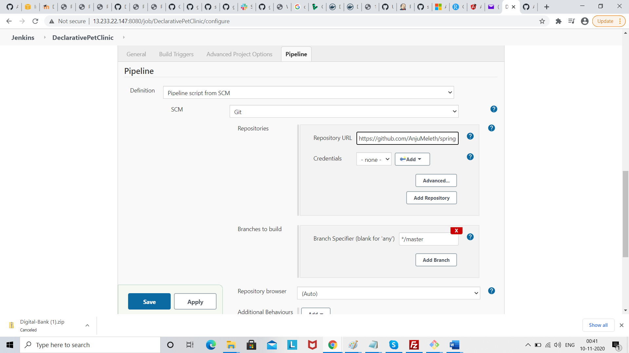

Click save build, and click build now

